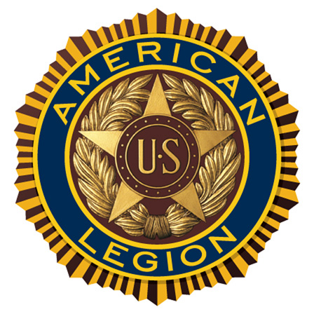 | American Legion Post 44  American Legion Riders Chapter 5  P.O. Box 1073  Elephant Butte, NM 87935  For God and Country – The American Legion | 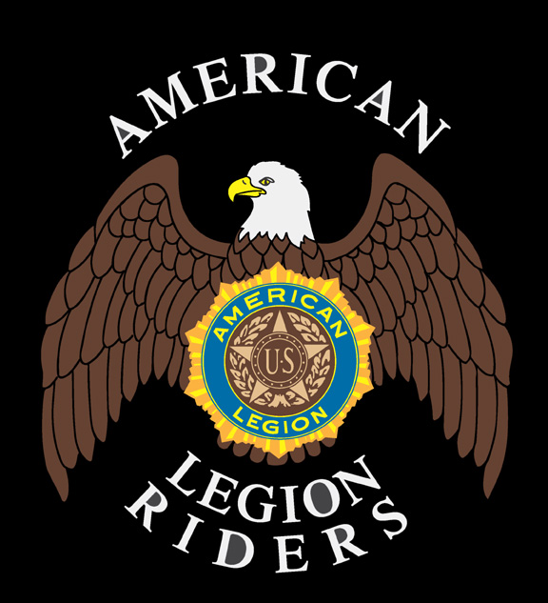

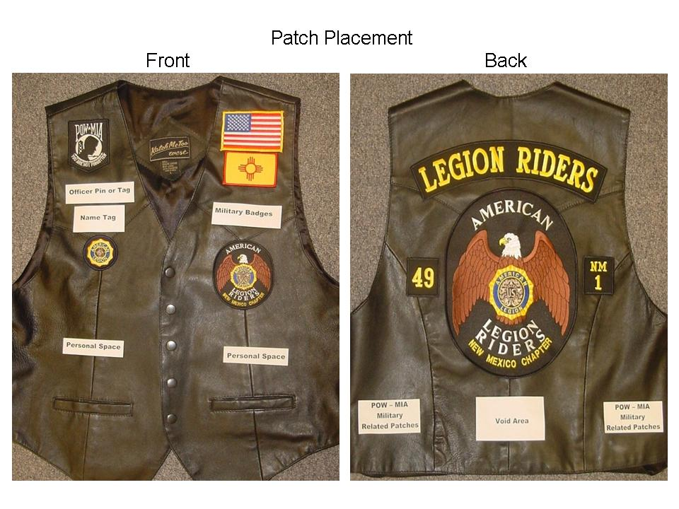

Wearing of Patches
- NMALR state and chapter patches will be worn on a black or brown leather or blue or black denim vest or jacket. No other colors of vests or materials are authorized for the NMALR vest.
- The front of the vest or jacket will consist of the following:
  - An American flag will be worn on the left side, high on the chest.
  - A New Mexico state flag will be placed immediately below the American flag.
  - The four (4) inch American Legion Riders Association patch will be placed beneath the New Mexico state flag.
  - No more than four (4) pins can be placed in the area between the four(4)inch American Legion Riders Association patch and the NM state flag. These pins must be of military, religious or personal significance.
  - A black POW/MIA patch will be worn on the right side, high on the chest. A red POW/MIA patch may be worn to denote service “in country”.
  - Beneath the POWMIA patch the appropriate two(2)inch American Legion, Auxiliary or Sons of the American Legion emblem will be worn.
  - Road names and officer titles will be worn between the POWMIA patch and The American Legion, Auxiliary or Sons of The American Legion emblem, with the officer title above the road name. State officer badges are gold in color while Chapter officer badges/patches are white or silver in color. All road name patches will have gold colored lettering. No other pins or badges are worn in this area.
  - The lower half of the left or right front of the vest or jacket is free for individual patches and pins.
  - Absolutely nothing will be worn above the American Flag or the POW/MIA patch, i.e. on the top of the shoulders of the vest or jacket.
- A two (2)-piece patch has been adopted by the NMALR Association for wear on the back of the vest or jacket. Nothing is to be worn above this patch.
- The back of the vest or jacket will consist of the following:
  - The American Legion Riders Association patch centered on the back.
  - The center of the vest or jacket, all the way to the bottom, beneath the ten (10)inch American Legion Riders Association patch will be void of all patches and pins.
  - A top rocker with "Legion Riders" or "Legion Riders" with "Charter Member" beneath, as applicable based on member's membership status, will be centered above the Association patch.

  - A 2X2 inch patch with "NM" and the appropriate Chapter number will be centered on and to the right side of the Association patch.
  - A similar patch with the member's appropriate post number will be centered on and to the left of the Association patch.
  - The area above the horizontal line between the post and chapter patches, up to and including the top seam of the shoulder and collar will be void of any pins and patches except as described herein.
  - The bottom left and right rear sides are designated for military service, unit or POWMIA related patches.
  - The top rocker and both side patches will have a black background with yellow block style lettering
- An associate's vest/jacket will be the same as an Association member's vest/jacket except that the back top rocker will consist of the words "Legion Riders" with "Associate" beneath and be centered above the Association patch.
- No support pins or patches for motorcycle clubs or their support organizations shall be worn on The American Legion Riders vest, jacket, chaps or any other apparel while wearing The American Legion or The American Legion Rider emblems.

Patches may be obtained from the following sources:
Online at American Legion Flag and Emblem
Locally through your chapter secretary; depending on availability
Mary Gomez for handmade rockers, name tags etc. 575-740-3486
Zia Graphics in Albuquerque for the smaller 2”x3” New Mexico Flags
Galaxy Army Navy (www.glxy.com) for the smaller 2”x3” American flags

